

Semester One Examination, 2019

Question/Answer booklet

Yr 12 SPECIALIST
UNIT 3

Section Two:

Calculator-assumed

Your Name

Your Teacher’s Name

Time allowed for this section
Reading time before commencing work: ten minutes
Working time: one hundred minutes

Materials required/recommended for this section
To be provided by the supervisor
This Question/Answer booklet
Formula sheet (retained from Section One)

To be provided by the candidate
Standard items: pens (blue/black preferred), pencils (including coloured), sharpener, correction fluid/tape, eraser, ruler, highlighters

Special items: drawing instruments, templates, notes on two unfolded sheets of A4 paper, and up to three calculators approved for use in this examination

Important note to candidates
No other items may be taken into the examination room. It is your responsibility to ensure that you do not have any unauthorised material. If you have any unauthorised material with you, hand it to the supervisor before reading any further.

Structure of this paper

Section | Number of questions available | Number of questions to be answered | Working time (minutes) | Marks available | Percentage of examination
Section One:  Calculator-free | 7 | 7 | 50 | 49 | 34.5
Section Two:  Calculator-assumed | 13 | 13 | 100 | 93 | 65.5
 |  |  |  | Total | 100

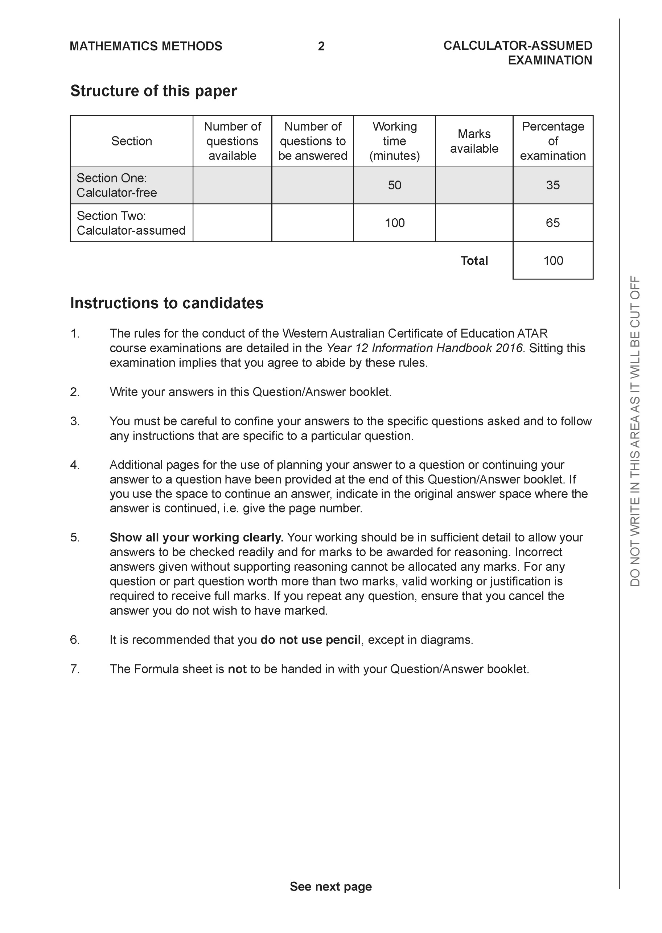

Section Two: Calculator-assumed (93 Marks)

This section has 13 questions. Answer all questions. Write your answers in the spaces provided.

Spare pages are included at the end of this booklet. They can be used for planning your responses and/or as additional space if required to continue an answer.
● Planning: If you use the spare pages for planning, indicate this clearly at the top of the page.
● Continuing an answer: If you need to use the space to continue an answer, indicate in the original answer space where the answer is continued, i.e. give the page number. Fill in the number of the question that you are continuing to answer at the top of the page.

Working time: 100 minutes.

Question 8 (6 marks)

- Sketch the following region in the complex plane, (3 marks)

Solution

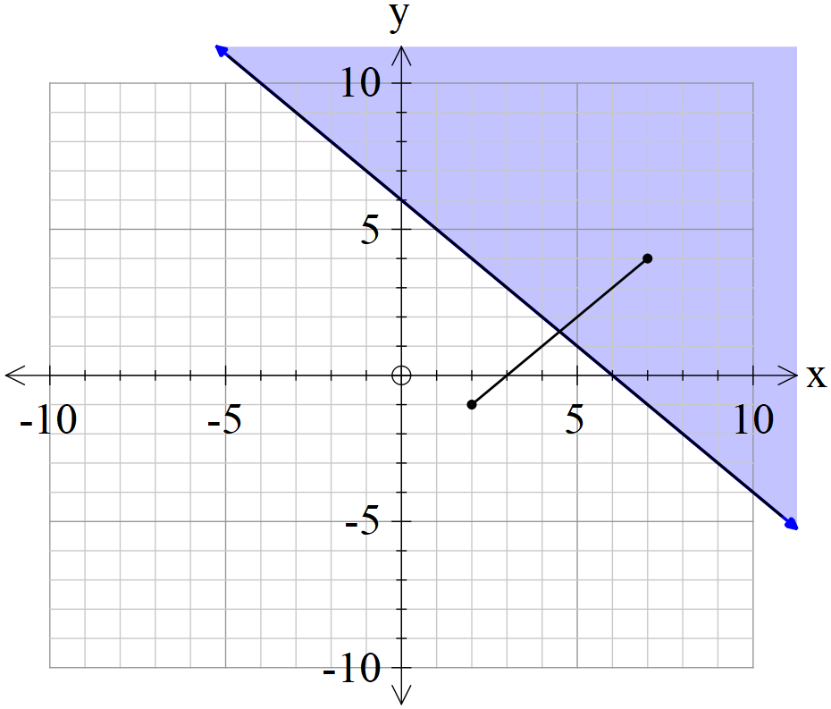

Specific behaviours
plots points
draws perpendicular bisector
shades correct region and includes line

- Determine the cartesian equation of (3 marks)

Solution
Midpoint

Specific behaviours
uses midpoint
uses perpendicular gradient
states cartesian gradient
OR
uses subs z=x+iy
determines magnitude of both sides
squares both sides and simplifies to find cartesian rule

Question 9 (6 marks)

- Given that , where is a constant, is only true for , determine the value of .
(3 marks)

Solution
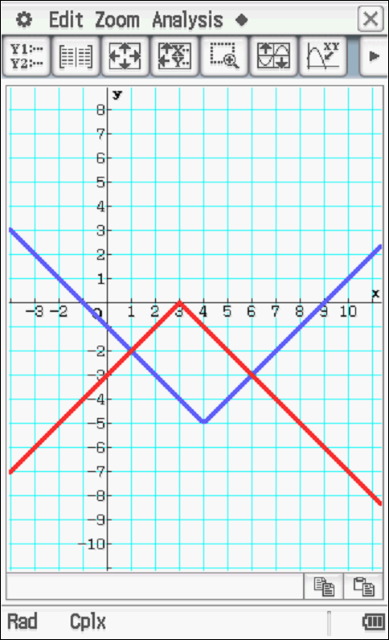
At x=1 -2=-|1+a| a=-3 or 1
At x=6 -3=-|6+a| a=-3 or -9
Common value a=-3

Specific behaviours
equates y values at x=1
equates y values at x=6
determines common value of a

- Given that , where are constants, is only true for , determine the values of . (3 marks)
Solution
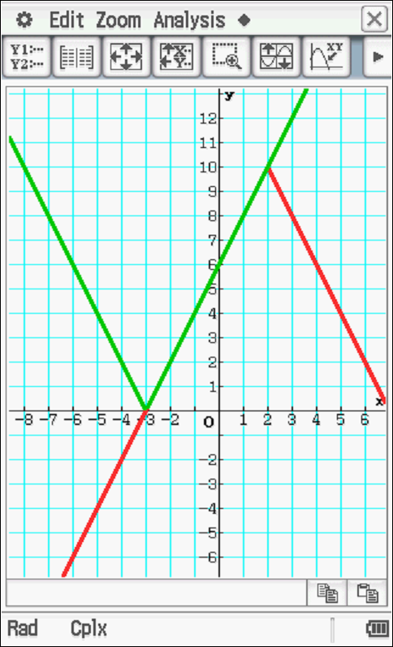

Specific behaviours
determines a
determines b
determines c

Question 10 (8 marks)

Consider the locus of points on in the complex plane.
- Sketch this locus below. (2 marks)

Solution
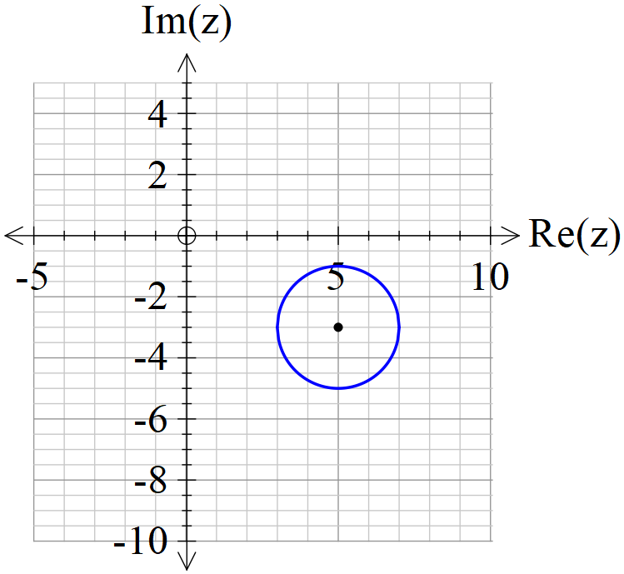

Specific behaviours
circle shape
correct centre and radius

- Determine the minimum principal on this locus. (3 marks)

Solution
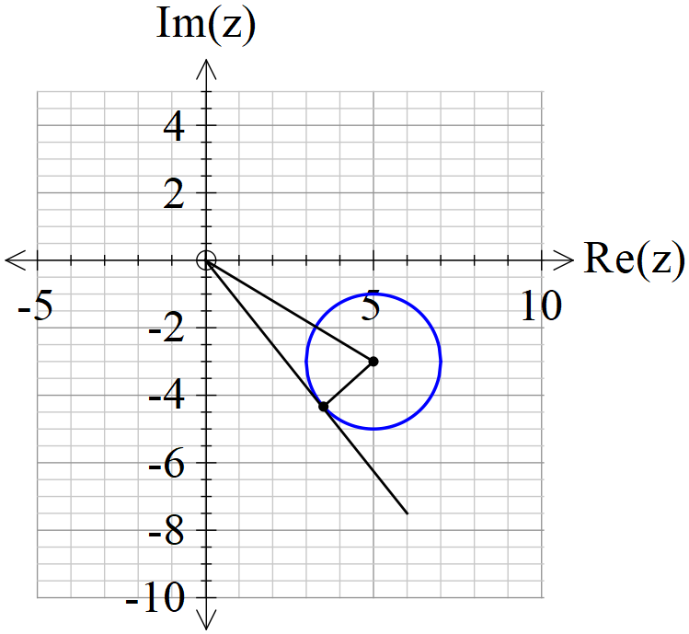
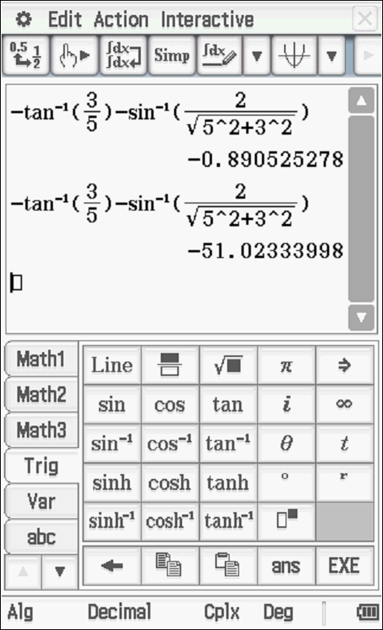

Specific behaviours
determines argument of centre
adds argument with triangle of tangent
states the principal argument(does not need to be rounded)

- Determine the maximum value of on this locus. (3 marks)

Solution
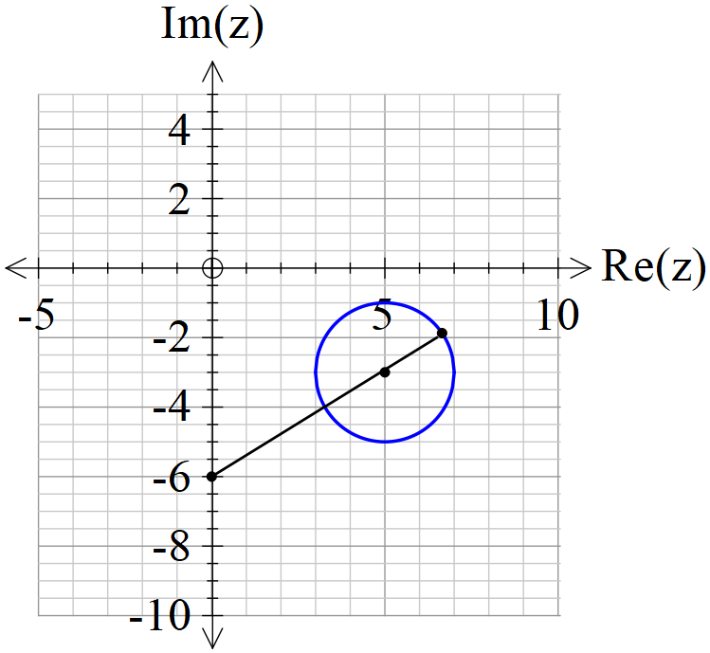
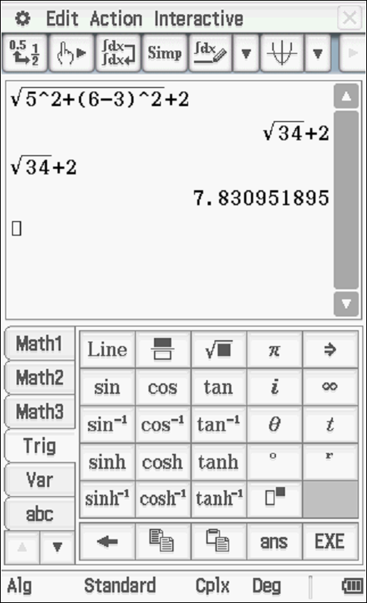

Specific behaviours
recognizes distance from -6i
determines distance to centre
determines maximum distance

Question 11 (5 marks)

Show that the line is parallel to the plane and determine its distance from the plane.
Solution
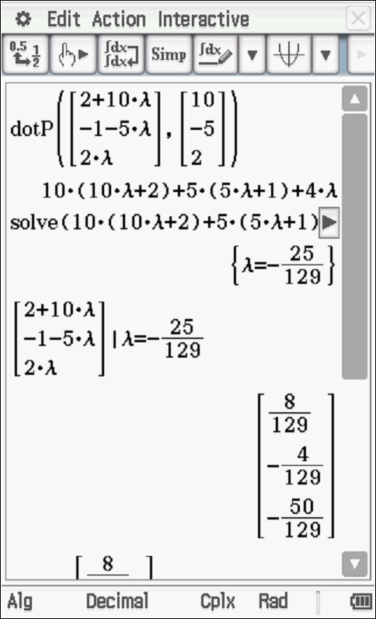 | 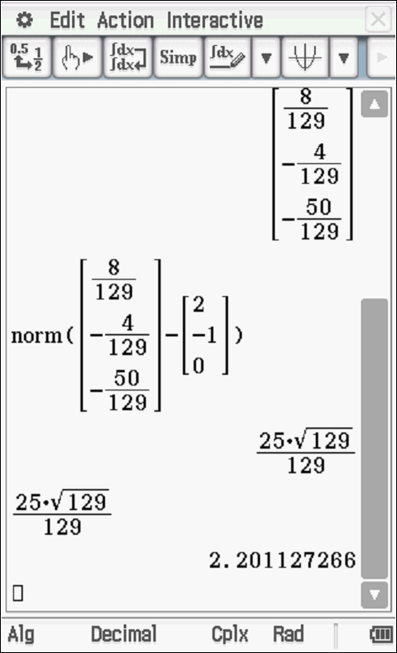

Specific behaviours
identifies vector parallel to line
shows that normal perpendicular to line
uses a normal line through a point on line
solves for where line meets the plane
determines distance from plane.
OR
determines point on plane
determines vector between point on plane and point on line
determines unit normal vector
uses dot product to determine distance
determines distance

Question 12 (5 marks)

Let , where , consider the sum .
- Sketch a diagram of this sum in the complex plane. (2 marks)

Solution
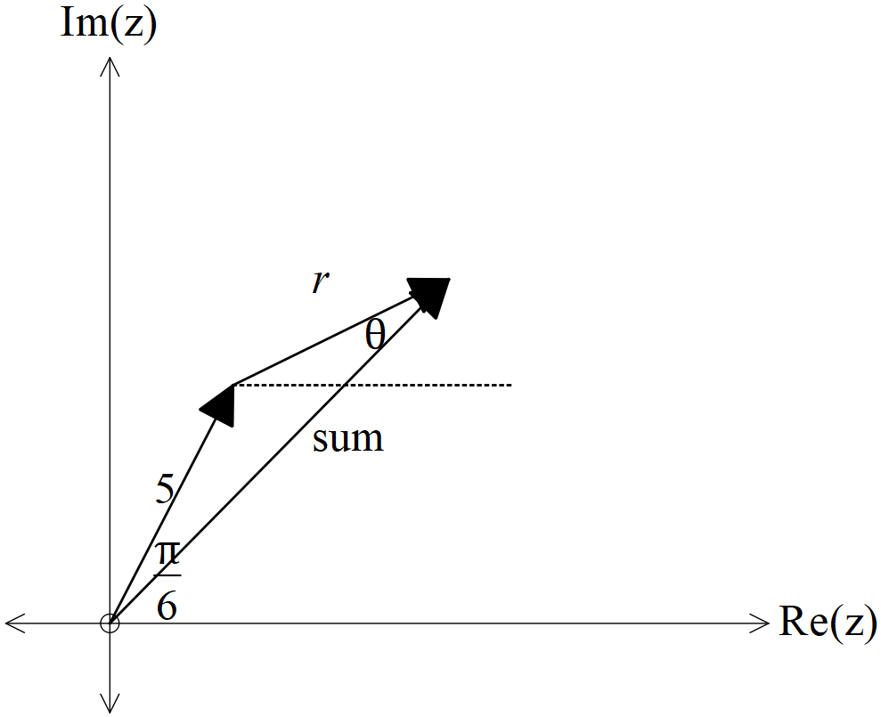

Specific behaviours
denotes angles and lengths of arrows
adds numbers as vectors

- Obtain an expression for the in terms of . (3 marks)
Solution
Specific behaviours
uses cosine rule
determines opposite angle to modulus
obtains correct expression

Question 13 (6 marks)

- Determine a vector that is perpendicular to both and and has a magnitude of .(Do not simplify) (3 marks)

Solution
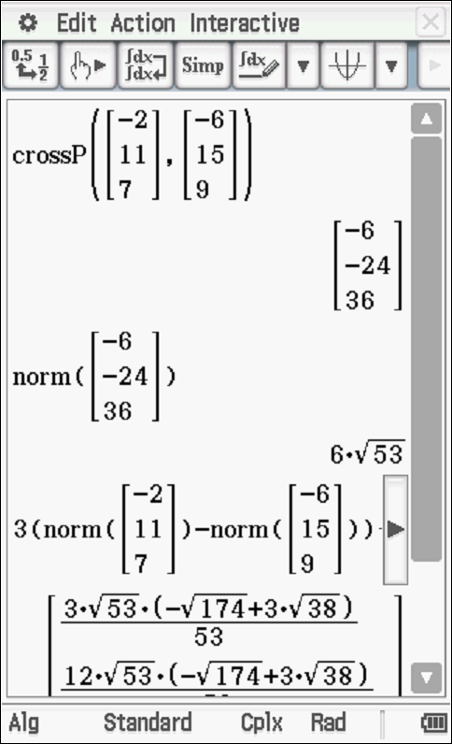 | 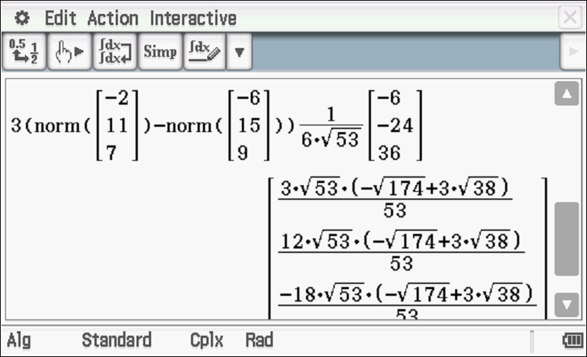

Specific behaviours
uses cross product
uses unit vector
uses magnitudes of all vectors to determine correct vector

- Let and where is a real constant. In terms of , determine an expression for the angle between . (3 marks)

Solution
Specific behaviours
uses dot product
determines magnitude of both vectors
determine an inverse cosine expression

Question 14 (10 marks)
Consider a plane defined by .
- Determine a normal vector to this plane. (1 mark)

Solution
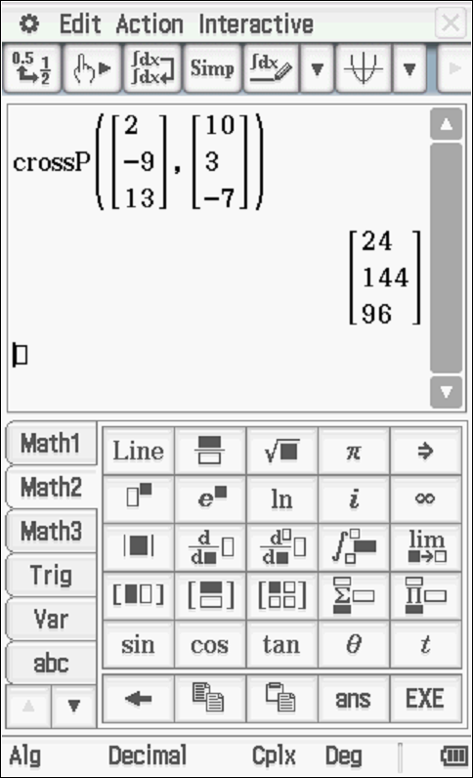

Specific behaviours
uses cross product

- Determine the cartesian equation of this plane. (2 marks)

Solution
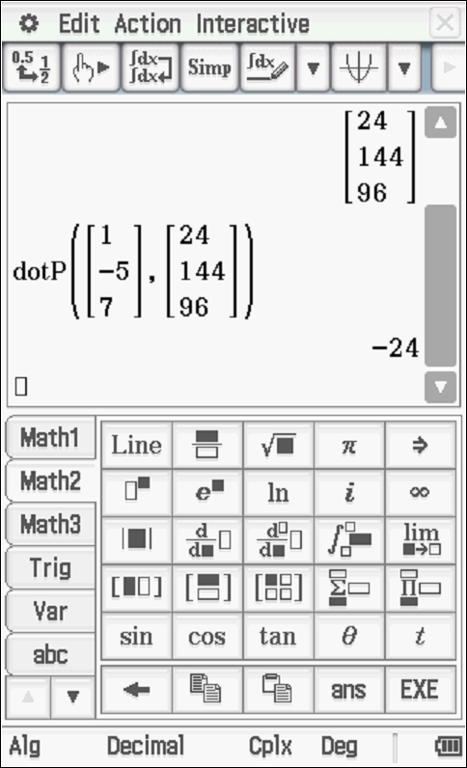

Specific behaviours
uses dot products with normal
determines a cartesian equation

- Show how to determine the distance of point from the plane above using scalar dot product and the normal vector. (4 marks)

Solution
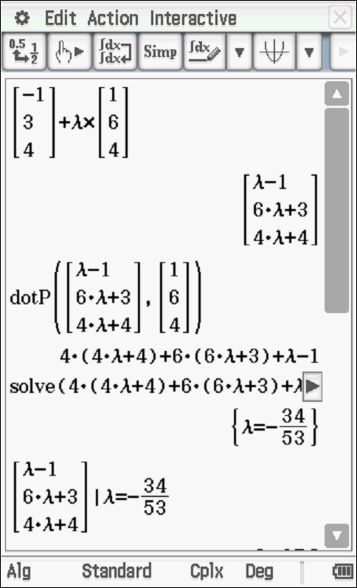 | 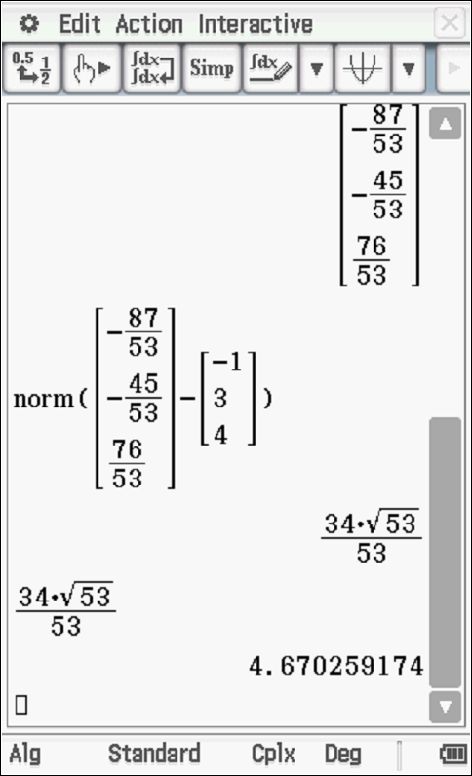

Specific behaviours
uses a normal vector through point
solves for where line meets plane using dot product
uses two points
determines distance
OR
determines a point on plane
determines vector from P to this point
determines unit normal
dot product between these two vectors

- Consider a general plane , where are constants. Show that the distance of point from this plane is given by the expression (3 marks)
Solution
Point on plane x=0=y

Specific behaviours
determines a point on plane
separation vector between this point and Q
uses dot product with unit normal

Question 15 (8 marks)

In deep space an astronaut is space walking outside a stationary space station. At time seconds the astronaut is positioned at metres relative to the space station and is moving with a velocity of metres per second. A rogue satellite is observed to be at position at time with a velocity of metres per second relative to the space station.

The satellite emits radiation and if the astronaut comes within 70 metres of the satellite the dosage will be harmful.

- Determine the distance between the astronaut and satellite at seconds.
(3 marks)
Solution
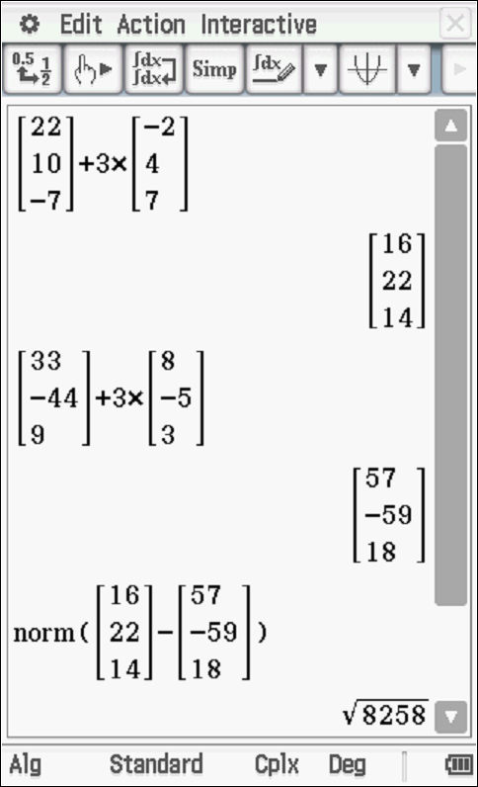

Specific behaviours
determines position of astronaut at t=3
determines position of satellite at t=3
determines distance apart

- Determine if the astronaut is in danger and if so for how long in seconds, 2dp.
(Justify your answer). (5 marks)
Solution
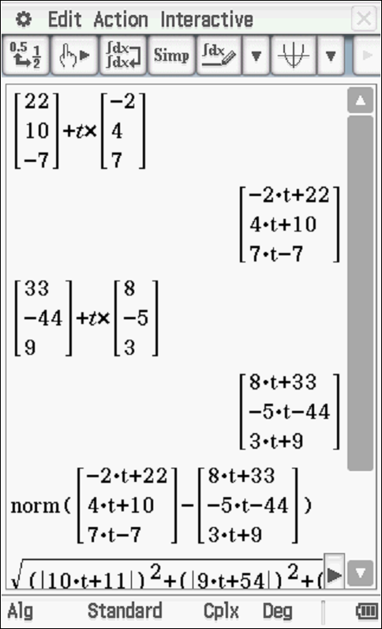 | ((abs(10*x+11))^2+(abs(9*x+54))^2+(abs(4*x-16))^2)^0.5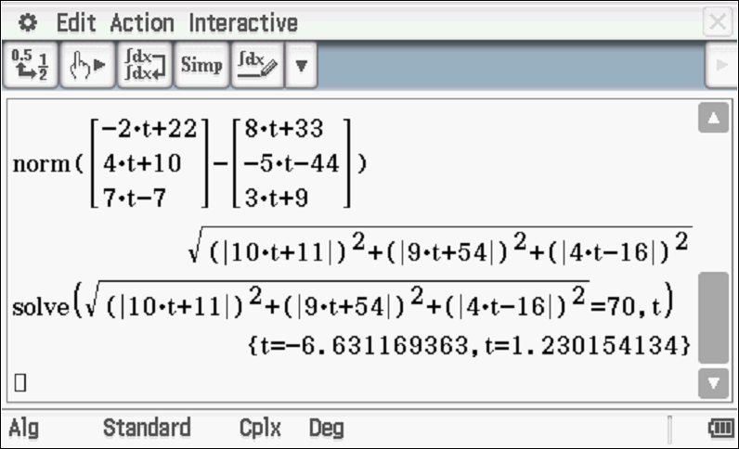

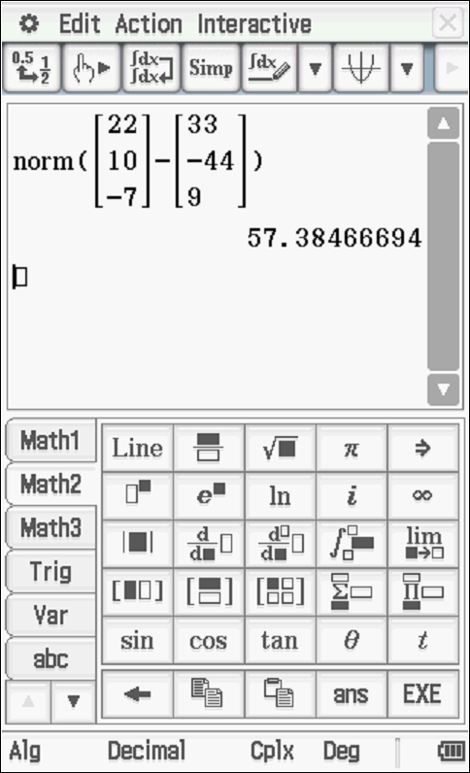

The first 1.23 seconds the astronaut is in danger.

Specific behaviours
determines position of astronaut at t seconds
determines position of satellite at t seconds
determines distance apart in terms of t
solves for time when distance apart equals 70 metres
determines time that astronaut is in danger

Question 16 (4 marks)

Consider the two spheres and .
Determine whether there are any common points on both spheres. Justify your answer.

Solution
Centre (-4,1,-1)
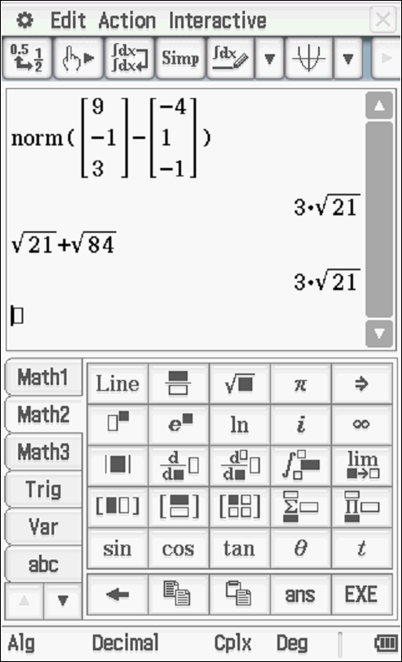
Only one common point as distance between centres equals sum of radii

Specific behaviours
determines centre of second sphere
determines radius of second sphere
determines distance between centres
shows that spheres touch at only one point

Question 17 (4 marks)

Show using vector cross product, how to determine the distance of point from the line .
Solution
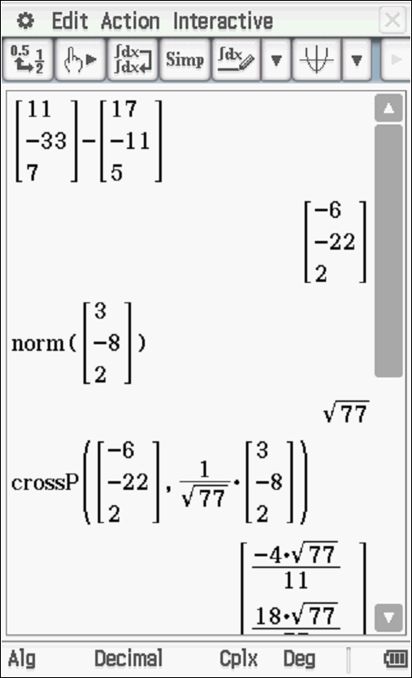 | 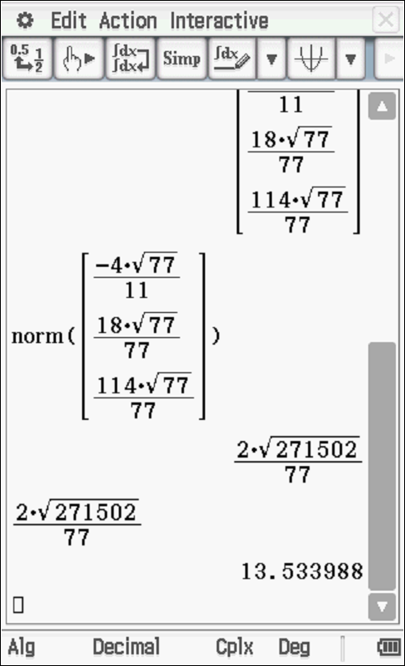

Specific behaviours
de3termines vector from point on line to pt A
uses cross product with vector parallel to line
uses unit vector
determines approx distance from pt A to line using cross product

Question 18 (9 marks)

Consider the line and the sphere where is a constant.
Determine the values of , to two decimal places, for each of the following scenarios:
(Justify your answers)
- the line does not meet the sphere at all.
- the line meets the sphere at two points.
- the line is a tangent to the sphere.
Solution
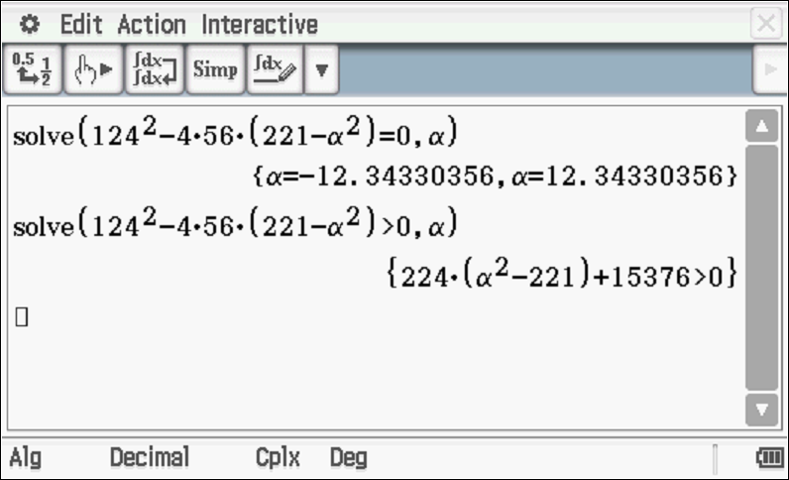
- alpha less than 12.34 but greater than zero
- alpha greater than 12.34
- alpha equal to 12.34

Specific behaviours
subs line into vector eqn of sphere
determines magnitude of left hand side
derives a quadratic equation for
determines an expression for det in terms of
equates det to zero and solves
only accepts positive values
determines values for not meeting
determines values for meeting at two points
determines value for scenario of tangent

Question 19 (13 marks)

Consider a prism where opposite sides are congruent parallelograms(parallelepiped) with coordinates .

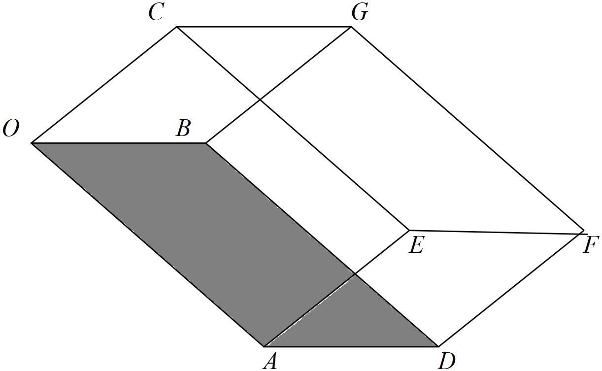

- Determine a unit normal vector to the base . (3 marks)

Solution
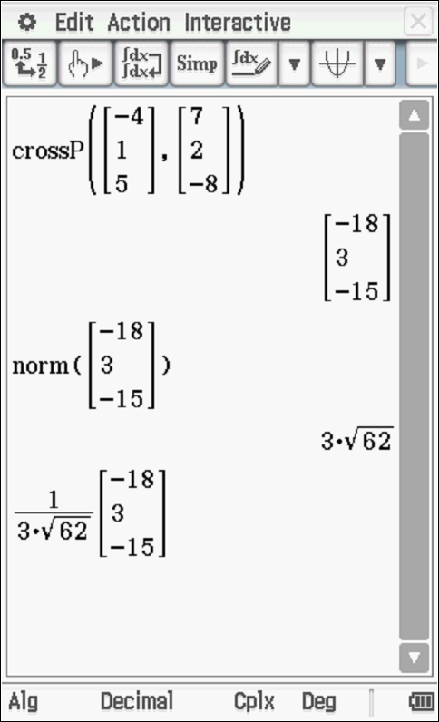

Specific behaviours
determines two vectors in base plane
uses cross product
determines unit vector

- Using this unit normal, determine the distance between the sides .
(Hint-use vector ) (3 marks)

Solution
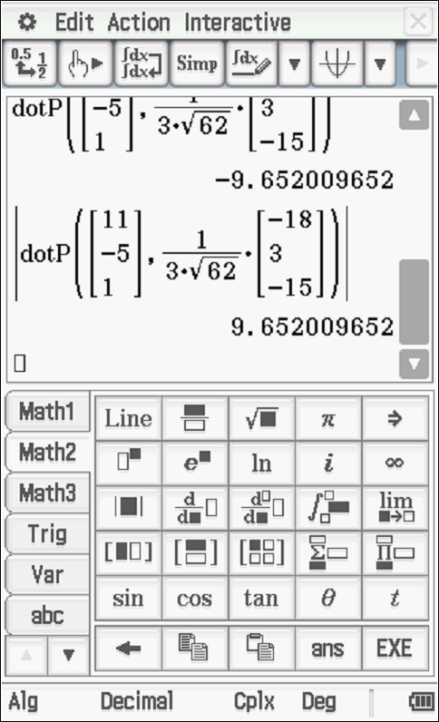

Specific behaviours
determines OC vector
uses dot product
determines distance

- Show using cross product how to determine the area of the base .
(2 marks)
Solution
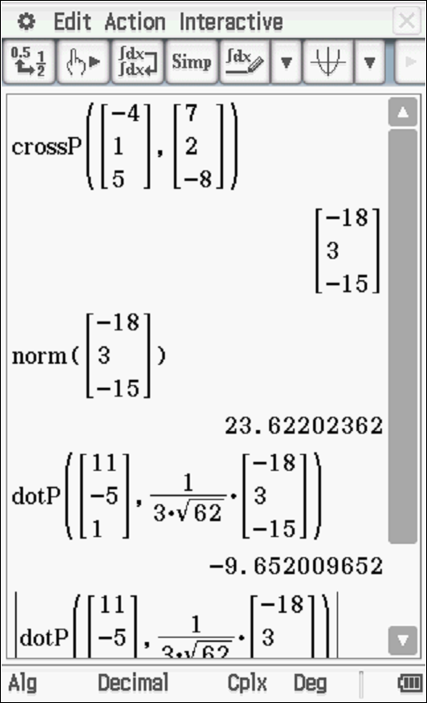

Specific behaviours
cross product of OA & OB vectors
determines magnitude

- Hence or otherwise, determine the volume of the prism. (3 marks)

Solution
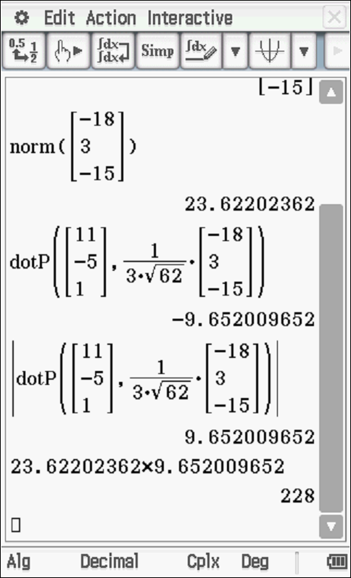

Specific behaviours
uses V=A*H
states area and height
determines volume

- In terms of the vectors write an expression using cross and dot products to represent the volume of the prism. (2 marks)
Solution
Specific behaviours
uses cross and dot product
uses absolute value

Question 20 (9 marks)

Consider a single photon of light that is released from a box positioned at point A and moves in a direction of hitting a planar sheet of glass at point B. The planar sheet of glass is given by . The photon is refracted, that is changes direction, through the glass such that the angle with the normal is and passes through point D.
It is given that the vectors and the normal are all in the same plane.

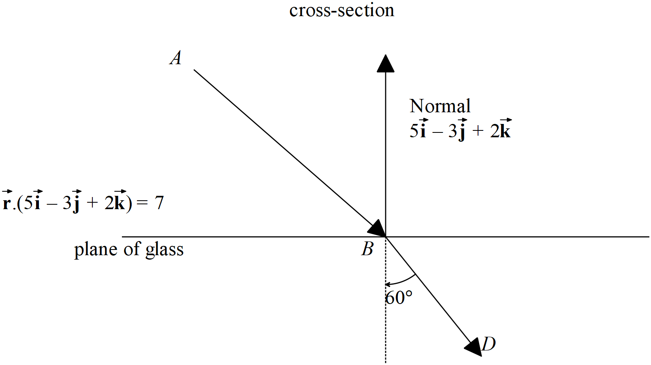
- Determine the point . (3 marks)

Solution
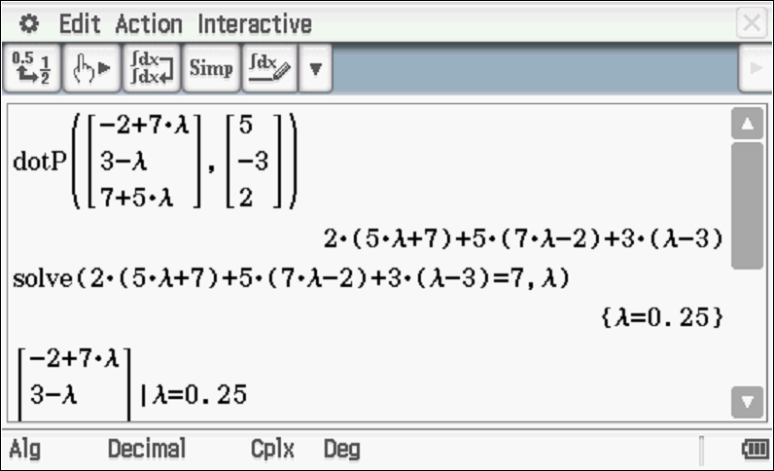
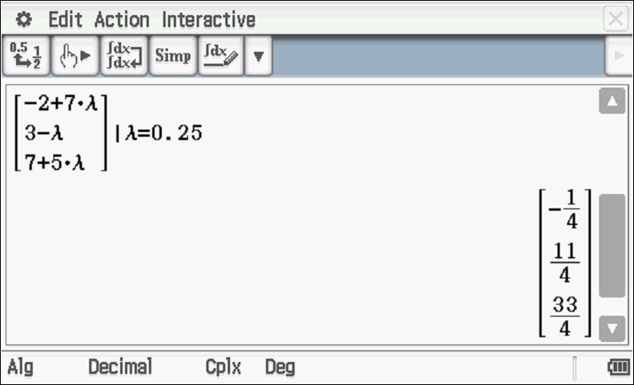

Specific behaviours
determines vector eqn of line of photon
sets up linear equation with vector eqn of plane
solves for point B

Let represent a unit vector and be represented as with
- Determine two other independent equations for . (4 marks)

Solution
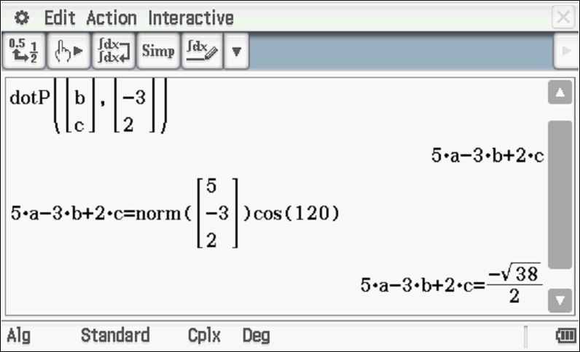
crossP([[7],[-1],[5]],[[5],[-3],[2]])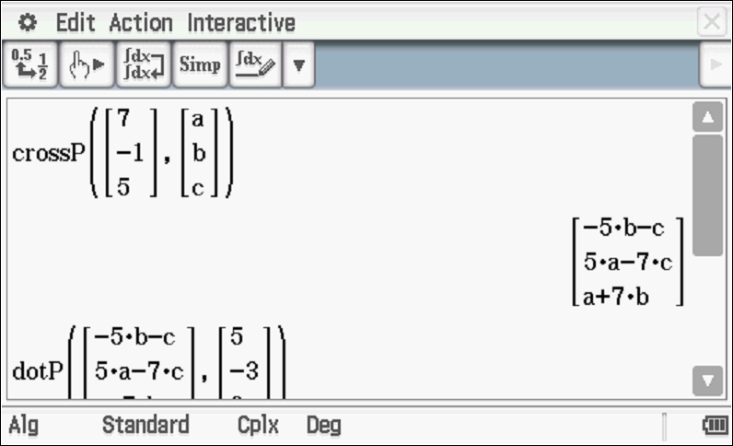
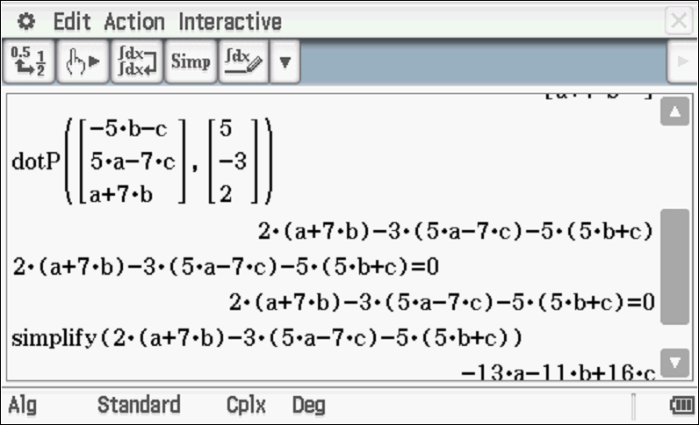
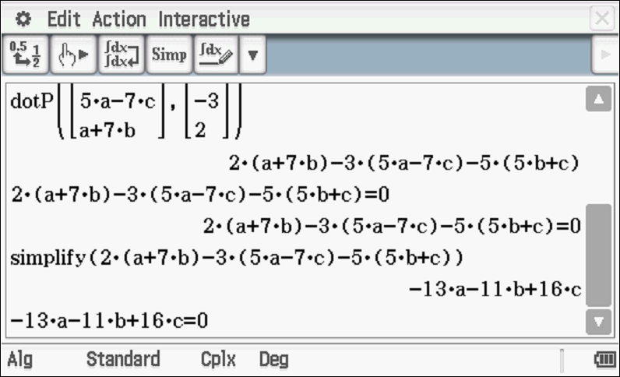
OR
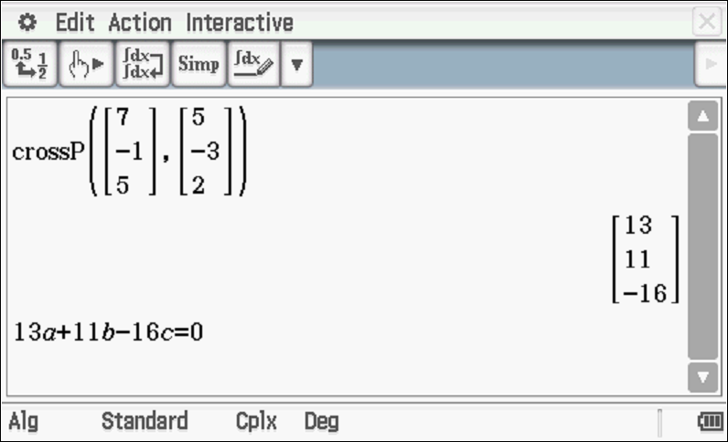

Specific behaviours
uses dot product with BD and normal
obtains an eqn in terms of a,b&c
uses cross product with BD
uses dot product of this cross product with vector in plane to derive second eqn
Question continued

- Hence solve for vector using your CAS calculator (simultaneous) to 2 decimal places.

Solution
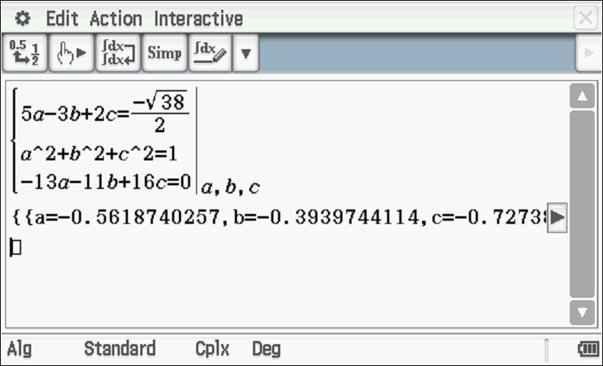
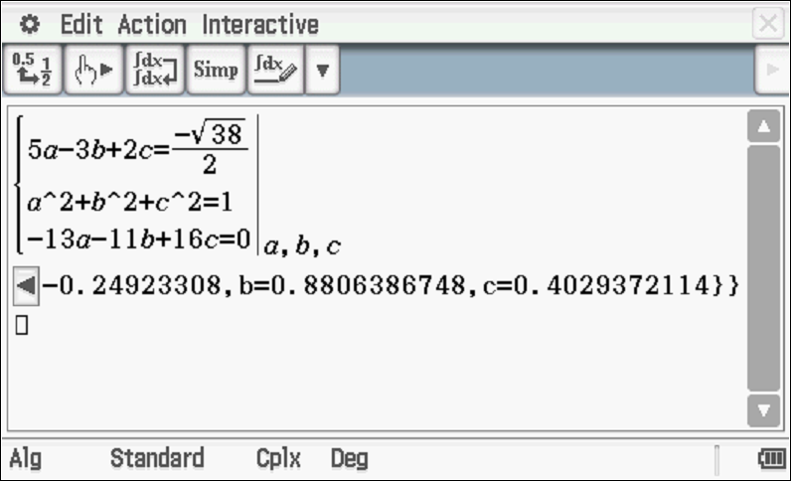

Specific behaviours
uses simultaneous mode on CAS with three independent eqns for a.b&c
solves for at least one set of values
NOTE: Follow through will only occur if correct ideas were used in setting up equations in b above.

Additional working space
Question number:

Additional working space
Question number:

